Term 1 - 7 – 12 Syllabus 2022
Back to Basics – The 5 Pillars of Islam
Lesson 1- Welcome to Scripture! (Setting the foundations for seeking Knowledge, Purpose of Life)
Lesson 2- Shahada Part 0ne (Who is Allah SWT)
Lesson 3- Shahadah Part Two (Who is Muhammad SAW)
Lesson 4- Pillar 2: Salah (Actioning the Shahadah)
Lesson 5- Pillar 3,4,5: Zakat, Sawm/fasting, Hajj
Lesson 6- The Quran (Basic knowledge)
Lesson 7- Ramadan Preparation and Revision

Important Teacher Notes:
- Please ABIDE by the syllabus
- You need to make sure your lessons for that week corresponds with the topic.
- It is VERY important to inform your school and supervisor if you are unable to attend your Scripture Class.
- For any inquiries or questions please contact your supervisor or the AIES office.
- Only use the approved links provided for each lesson.
- The AIES program is non-sectarian and is provided to all Muslims students, regardless of their sectarian groupings. The aim of AIES is to teach students to love, learn and live Islam.
- We welcome feedback or suggestions on how to improve the syllabus. Please email syllabus.isre@gmail.com attention High school.
Office: Level 2, Building 3, 20 Worth St, Chullora, NSW,2190 Tel: (02) 8377 4180 Email: info@islamiceducation.org.au
AIES Copyright © 2021 This resource is for not-for-profit educational or personal use only. Any form of commercial use is strictly prohibited.

IMPORTANT NOTE TO TEACHERS:

As-Salamu ʿAlaykum Dear Teacher,

Insha’Allah you are in the best of health and Iman. May Allah SWT reward you immensely for your teaching efforts. We encourage you to make scripture lessons as relevant and interesting as possible, so that students enjoy coming to scripture! Please try to support the participation of each student.

Da’wah (spreading the message of Islam) is recognised by the majority of scholars as being OBLIGATORY upon all Muslims. The Prophet SAW instructed us to “convey from me, even one verse.” (Bukhari). As teachers we are fulfilling this obligation upon us Inshaa’ Allah.
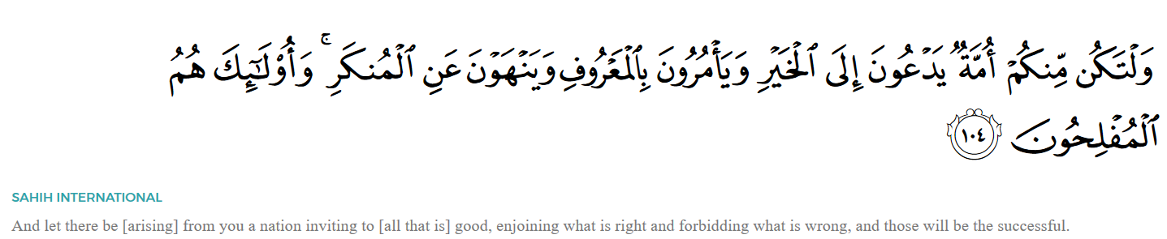
Investing your TIME to INSPIRE the Youth and teach the TRUTH!
The Benefits of Da’wah
- Achieving the pleasure of Allah Sub-hanahu Wa Ta’ala (Glorified and Exalted is He).
- You are given a great favour by Allah SWT to follow in the footsteps of the greatest man to walk upon the Earth (Muhammad SAW!) as a Da’ee.
- You are an ambassador of Islam, inspiring others weekly.
- “Allah (SWT), His angels and ALL those in the Heavens and on Earth, even ants in their ant-hills and fish in the water, call down blessings on those who instruct others to beneficial knowledge” (Tirmidhi).
- You are being part of the change you want to see in the world! Your incredible efforts are continuing to inspire and improve the spiritual development of our future generations.
- You are strengthening your own relationship with Allah SWT. The knowledge you read and share weekly, increases your knowledge and spiritual growth.
- By giving Da’wah and passing on authentic knowledge, we are also protecting ourselves from the punishment of Allah SWT.
Notes on Abbreviations used throughout Syllabus:
***Please explain the importance and meaning of these salutations and encourage students to use these regularly. Please say these words in their entirety (e.g., “Sub-hanahu Wa Ta’ala”). Do NOT say the lettered abbreviation (e.g., “SWT”).

- SWT- Sub-hanahu Wa Ta’ala- May He be Glorified - used after Allah’s glorious name.
- SAW- SalAllahu alayhi Wassalam - used after the Prophet Muhammad’s name as a mark of respect and to say ‘May Allah SWT’s peace and prayers be upon the Prophet.’ (SAW is used interchangeably in the Syllabus).
- AS- Alayhissalam- May Allah SWT peace be on them - used after the name of other Prophets.
- RAA- RadhiAllahu'anhu / RadhiAllahu'anha- May Allah be pleased with him/her.

Teachers are kindly reminded:
- Follow the Syllabus closely
- Encourage worship by instilling the love of Allah SWT and our Deen (religion).

- NOT to discuss sects, politics or other religions.

- NOT to discuss hellfire, hate, the grave, punishment, jinn’s/Devils.

TEACHING TIPS
The Prophet PBUH taught Islam to so many people around him. A companion once said: “I’ve never seen any teacher gentler than the Messenger of Allah (PBUH).” (Abu Dawud 931). We can utilise some of the Prophets’ teachings to help us teach scripture, for example:
- Maintain direct eye contact with listeners- make students feel valid.
- Repeat lesson in different ways, at level of student comprehension
- Ask questions to spark curiosity and interest (aligned with the syllabus)
- Use questions to elaborate and expand
- Speak in a measured tone (appropriate to discussions)
- Use daily life examples/illustrations/gestures/visuals or objects to help explain points
- Give time between words for listeners to process information
- Have an attitude which shows kindness, gentleness, warmth and care to all students
CLASSROOM MANAGEMENT
“The rights of your students on you is that you should understand that in granting you knowledge and opening its path to you, Allah SWT has appointed you to be their guardian. Therefore, you teach them properly and do not frighten them or be furious with them, Allah SWT in turn, will through His mercy, increase your knowledge too. But if you drive the people away from knowledge and, as and when they approach you for it, you frighten them and get annoyed with them, it will only be appropriate that the Almighty Allah may take away the light of knowledge from you and may degrade you in the eyes of the people."
Some suggestions for maintaining a safe, respectful and engaging classroom:
- BE PREPARED by reading the syllabus ahead of time. Being prepared gives added confidence and allows more time for thinking about ways to tailor lessons for your specific class (remember to run ideas by your supervisor). Watch suggested video links prior to class.
- Get to know your students: Take the opportunity at the beginning of each year (or term) to learn students’ names and a bit about them. Building positive relationships is key to engaging students and managing behaviour in the classroom!!
- Remain calm and positive! When you are calm, controlled and enthusiastic, you generate this positive energy to your students and model correct Islamic behaviour.
- Praise! Praise! Praise! Encouragement goes a long way. Learn student’s names if you can and recognise students’ efforts.
- Break up the lessons: Teachers should never spend the whole lesson talking themselves! Keep students actively engaged with discussions, small group work and short simple activities where the focus is not on the teacher. The Syllabus suggests activities to maintain engagement.
- Rules: Discuss classroom rules during the first lesson of scripture. Students will be less likely to break the rules if you remind them that they had decided this rule was important in the first place! Students should already be familiar with the school behaviour policy and you can remind them of this. The classroom teacher present may also help you if needed.
- Review and reflect: Occasionally you may need to stop everything and discuss respectful learning with the class, especially when discussing Allah SWT. Calmly, you can mention that Angels surround the classroom because we are all sitting together remembering Allah SWT and how pleased Allah SWT is with us right now.
- If there is no teacher present: Speak to the scripture co-ordinator after class, if you require assistance in class.
STARTING EVERY LESSON(S)
- SALAMS: We know that teaching scripture may sometimes be challenging, and that a good start to each lesson is important, so teachers should start each lesson enthusiastically, using the Islamic greeting:
“As-Salamu ʿAlaykum…” ‬ "peace be upon you"
Encourage students to respond with the reply of “wa-alaikum assalamu wa rahmatullahi wa barakatuhu,” CLEARLY (and may the peace and mercy and blessings of Allah be upon you). Please explain the meaning. Try to always use this greeting, as spreading this greeting was described in hadith as one of the best things that a Muslim can do! Remind them of the hasanat earned just giving the Salam alone.
- DUA: Teachers may find it helpful to then begin their lesson by reciting and explaining the following Dua of Prophet Musa AS with students. Teachers should explain that this Dua can be used to help with important tasks, speeches, to improve confidence and communication. Teachers can mention how saying it helps calm you as you start your lesson.

Rabbishrah lee sadree, Wayassir lee amree, Wahlul ‘Uqdatam-mil-li saanee,
Yafqahoo qawlee (Surat Ta-Ha, verses 25-28)

“O my Lord! Expand for me my chest (grant me peace, contentment and confidence); ease my task for me; and remove the impediment from my speech (remove incorrectness from my speech/ help me say the right things), so that they understand what I say.”

- AL FATIHA/BISMILLAH: Teachers may find it beneficial to start each lesson with Surat Al-Fatiha, or by saying “Bismillah” (in the Name of Allah) with students. We want students to understand that we start every good thing remembering Allah SWT. The syllabus aims to help increase an awareness and love of Allah SWT in our lives and in every act we do.
ENDING THE LESSON(S)
At the end of each lesson, try to conclude with the following closing Dua. The Prophet SAW informed us that if this Dua is said at the end of a gathering, Allah SWT will forgive us for any intentional or accidental mistakes we might have made during the gathering.
Subhanaka Allahumma wa bi hamdika ashadu an la ilaha illa anta astaghfiruka wa atubu ilayk
O Allah! You are free from every imperfection; praise be to you. I testify that there is none worthy of worship except you; I ask Your forgiveness and turn to You in repentance.

SYLLABUS STRUCTURE:
Lessons will generally contain the below structure/ information and icons:
LESSONS LEARNT / REFLECTIONS |  | ATTENTION TEACHER / PLEASE NOTE | or ***
DEFINITION/IMPORTANT KEY POINT/ BENEFITS |  | STORY (optional)
WHITE BOARD ACTIVITY (optional) |  | VIDEO LINKS (optional)

LESSON 1: Welcome to Scripture
Today, you will introduce yourself to the class, to get acquainted, build relationships, form group rules, and discuss basic understandings. Explain benefits of scripture as one of the most beneficial gatherings they will attend.
Outcomes:
- Students learn the purpose of Islamic scripture is to establish the remembrance of Allah SWT and gain beneficial knowledge of their purpose in life.
- Students understand the virtues and reward of the Islamic greeting.
- Students understand the importance and reward of religious gatherings and the Angels.
As-Salamu’alaykum everyone. [Encourage students to respond with the full reply of “wa-alaikum Assalamu wa Rahmatullahi wa Barakatuhu,” (and may the peace and mercy and blessings of Allah SWT be upon you)].
My name is _________ and I’m honoured that Allah SWT has selected me to be your scripture teacher this year, and selected you to be here today. Yes, selected…The Prophet Muhammad SAW said “Whoever is given an understanding of the deen/religion has also been given the Good News from Allah SWT” …and what is the Good News?
If Allah SWT intends goodness for someone, He gives him/her understanding of the religion.
(Source: Sahih Bukhari). In fact, that you are here today in this room is already an indication of Allah SWT love and guidance for you!
Islamic knowledge is OBLIGATORY on every Muslim, it is a command from Allah SWT to learn about your deen/religion.
The first knowledge you will gain are the virtues/merits of Salam!
Offering Salam to your fellow Muslim(s) is an Islamic duty, as is replying back to the Salam. Allah SWT is so merciful that He has made everything we say of value and reward/hasanat. Are you aware of the hasanat you get for simply greeting another Muslim?
The Prophet SAW said, "He who says As-Salamu’alaykum (Peace be upon you) ten rewards are written down for him, and he who says As-Salamu’alaykum wa rahmatu Allah (Peace be upon you and Allah’s mercy) for him twenty rewards are written down and he who says As-Salamu alaykum wa Rahmatullahi wa Barakatu (Peace be upon you and Allah’s mercy and blessing) thirty rewards are written down (for him)."
Sharing this greeting among each other is like a signed contract whereby you will only receive respect and peace from me Inshaa’ Allah and vice versa- I expect peace/Salam from you- no bad choices in regards to your manners and behaviour Inshaa’ Allah.
Let us begin…What is our purpose in life?
Why did Allah SWT create us? Why did He wake you up today? To simply eat and drink, play, scroll through multiple pointless videos, play video games? No, you and I were created with a much higher purpose and Allah SWT has made it CRYSTAL CLEAR what He wants from us.
“I have created the jinn and humankind only for My worship.” (Qur’an 51:56)
What is worship? Does it mean only rituals like salah, fasting reading Qur’an, no playing or no fun. Worship to your surprise is not limited to these acts only, in fact we will learn in scripture your entire actions can become worship if done correctly! Worship can be everything you do inwardly and outwardly that Allah SWT loves and approves. Yes, even having fun and playing can be worship if it is done correctly within the guidelines of Islam (as we will learn).
However, Allah SWT is not in need of our worship. Meaning If not a single human worshipped Allah SWT, it would not weaken His glory in any way, nor would His glory be increased if everyone believed in Him. Allah SWT is perfect, He exists without any needs. However, we are limited and have many needs, this why we NEED Allah SWT! Every breath you take is ONLY done so, with the permission of Allah SWT. This is our purpose in life: to consistently remember Allah SWT in everything we do.
The Angels of Gathering-(either explain or watch the video of this to encourage students to come to scripture).
The Prophet SAW said: “No people sit in a gathering remembering Allah SWT, But the angels surround them, mercy covers them, tranquillity/peace descends (comes down) upon them and Allah SWT remembers them before those who are with Him”. (Sahih)

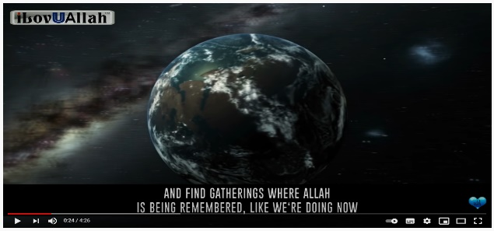
Subhan Allah, Allah SWT is so amazing! That’s why we say, ‘Subh'anaHu Wa Ta-A'la’ (SWT) after we say His name - it means, ‘how glorious and magnificent is Allah!’
https://youtu.be/EsOSYt45SnI
The Angels of The Gatherings | Amazing Hadith

(**Hadith in full detail below for teachers to read or select a student(s)- if there is no access to a smart board).

Abu Huraira RA reported: Muhammad SAW said, “Verily, Allah Almighty has caravans of angels who have no other work but to follow gatherings of remembrance. When they find such gatherings in which there is remembrance, they sit with them and some of them surround the others with their wings until the space between them and the heavens is covered. When they disperse, they ascend to the heavens and Allah Almighty asks them, although he is best informed about them: From where have you come? They say: We came from your servants on earth who were glorifying you, declaring your greatness and oneness, praising you and asking from you. Allah says: What do they ask from me? They say: They ask for your Paradise. Allah says: Have they seen my Paradise? They say no. Allah says: What if they were to see my Paradise? They say: They seek your protection. Allah says: From what do they seek my protection? They say: From your Hellfire, our Lord. Allah says: Have they seen my Hellfire? They say no. Allah says: What if they were to see my Hellfire? They say: They ask for your forgiveness. Allah says: I will pardon them, give them what they request, and grant them protection. They say: Our Lord, there is one among them, a simple servant who happened to pass by and sit there alongside them. Allah says: I will also grant him pardon, for whoever sits with these fellows will not suffer misery.”
Think about how special you are right now to Allah SWT. Now imagine having this blessing every week, whereby your name is mentioned in the Heavens! Please make the effort every week to attend these lessons. This term, we will be remembering, thinking, applying and discussing Islam and what makes us Muslim and how to become better Muslims Inshaa’ Allah.

Lesson Learnt/reflection

- Seeking Islamic knowledge is compulsory for every Muslim. The Prophet Muhammad SAW said: “Whoever travels a path in search of knowledge, Allah will make easy for him/her a path to Paradise.” (Sahiḥ Muslim). As you travel this path every week Allah SWT will guide you inshaa Allah to more goodness that will lead you to Jannah!
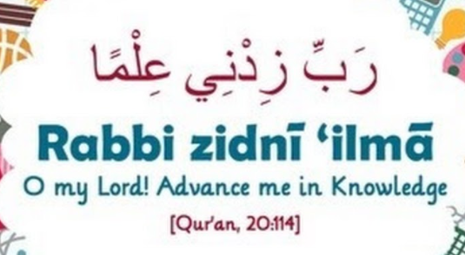
Dua to say every day for knowledge:
(Repeat this every lesson to remind).

- Our Prophet SAW told us: “He who remembers his Lord and he who does not are like the living and the dead.” (Bukhari & Muslim)
Please make the effort to arrive on time and settle quickly, as we only have a limited time to earn rewards. Please also encourage your friends to come to Scripture (you will in turn gain extra rewards/hasanat for everything your friend(s) learn(s).

LESSON 2: SHAHADAH PART 1
To become a member of any group, team you are required to follow rules, or terms and conditions, just like your code of conduct at your school, or an employment somewhere or even a citizen in a country. If we really want to be part of something, we make a commitment to follow rules and apply them. The Five Pillars are the basic foundations of being a Muslim.
The Prophet SAW said: “Islam is built on five (pillars): bearing witness that there is no god except Allah and that Muhammad is the Messenger of Allah, establishing prayer (salah), paying zakah, Hajj and fasting Ramadan.” (al-Bukhaari, Muslim).
Allah SWT has made these 5 Pillars obligatory in order to keep us guided on the straight path (Sirat Al-mustaqueem).
**Reminder to students; Whenever the name Allah SWT is mentioned we should say “subhanahu wa Ta'ala" (may He be glorified) out of respect for Allah SWT. Whenever we hear or mention Muhammad we say, “sallallahu alayhi wa salaam” (may Allah SWT’s peace and prayers be upon the Prophet. (This will increase your love for Muhammad SAW. Allah SWT will bless you and raise your rank also).
Let’s begin…
Significance/ Importance of the Shahadah:
Why are you Muslim? is it just because you were born into a Muslim family? What really makes you a Muslim? The Shahadah- testimony declaration of faith, is the first and most important Pillar because it is what makes you a Muslim. There are 2 parts to the Shahadah:
Firstly, that you believe and are certain without doubt: There is no God but Allah- Ashhadu ina lā ʾilāha ʾ illā llāh and secondly that Muhammad SAW is His Messenger: wa ashadu ana muḥammadun rasūlu llāh.
Today we will dissect and truly understand the first part:
Ashudu: means you testify: like in the courtroom and they ask you to make a statemen/testify the truth for example.
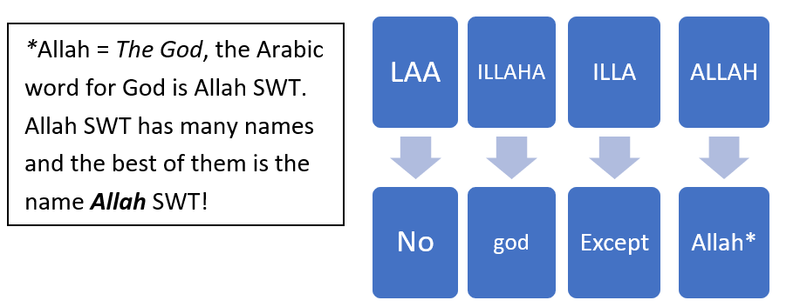
(Teacher please do not assume students know what this means dissect it clearly) Write this on the board clearly and spaced out to explain:

So, you are asserting/stating that there is No God/deity but Allah SWT worthy/deserving of your worship or obedience. This is called Tawheed (write this on the board), Tawheed is to single out Allah with ALL worship. This means you do not pray/worship idols, statues, people, Prophets, imams, graves or saints or ANY CREATION rather we WORSHIP THE CREATOR. How can anyone or anything deserves our worship/ibadah EXCEPT the one who made us- the creator who is AHAD/One and only, He is AS SAMAD/ limitless, perfect- no imperfections (Surah Ikhlas).

The first thing we need as Muslims is Knowledge of Allah SWT…
Who is Allah?
The most common name known is Ar-Rahman (the merciful) and Ar-Raheem (entirely merciful). Out of all His qualities Allah SWT choose these names to introduce Himself to us, over and over again. It is only out of the mercy of Allah SWT we are fed, provided for, breathing etc. Allah SWT instils His mercy throughout the world in all His creations. However, the Prophet SAW said: Verily, there are one hundred (100 parts of) mercy for Allah, and it is one (1) part of this mercy by virtue of which there is mutual love between the people and ninety-nine (99) (parts) reserved for the Day of Resurrection. [Sahih Muslim] https://youtu.be/WM1dbujFjgE
Allah SWT is Al-Malik, The King, Owner of everything seen and unseen. We live in His Kingdom; therefore, it is understandable that He makes the rules and sets the terms and conditions. Everything belongs to Allah SWT and everything returns back to Him.
Allah SWT is Al-Khaliq- the creator of everything in the universe seen and unseen and Al-Khalaaq- the one who is constantly creating e.g., as you sit here in this room, over 100 million new red blood cells are being formed in your body every minute! And now think for a moment and reflect on how many billions and billions of creations there are on this Earth alone, every ant, grain of sand, every bird, every tree, every plant, every atom and truly understand that Allah SWT is in control of each and every one! Subhan Allah (how perfect is He) You can only be in awe of His greatness! And what about the unseen, the galaxies, the heavens, the Angels! La illaha illa Allah (No God but Allah) who can dare to compare?
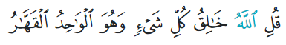
“Allah is the Creator of everything. He is the One, the All-Conquering.” (Surat Ar-Ra‘d, 13:16)
Allah SWT tells us to look for His existence in the universe, we can see without a doubt that every single thing in creation- has the signature of the creator- Everything says made by Allah SWT.
(Show students follow images- best to show in colour print)
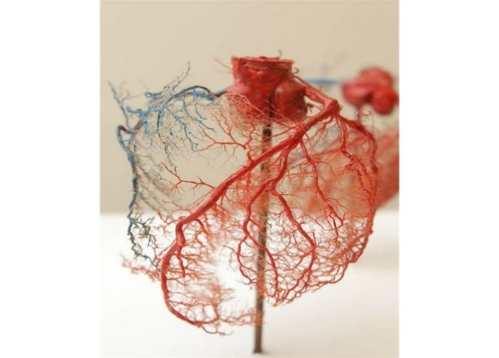
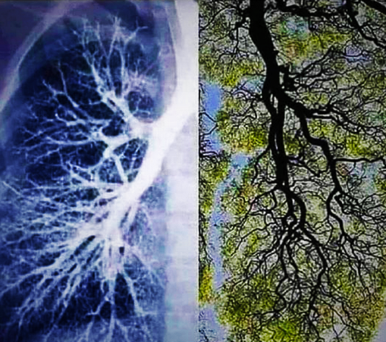
NOTICE THE SIMILARITIES HEART, LUNGS, TREES.
"And on the earth are signs (ayat) for the certain (in faith)." (51: 20)
When in every single thing there is a sign,
Revealing that He is the One! (Tafsir Ibn Kathir)

LOOK AT THE PERFECTION NO FLAWS AND THE GEOMETRIC, SYMMETRIC SHAPES IN NATURE SUBHAN ALLAH...THE SAME ONE/AHAD MANUFACTURER!
Surat Al-Ikhlāṣ (Sincerity, Quran: 112) tells us about Allah SWT. The chapter/ Surah is very short with only 4 Ayats (verses/sentences) but tells us a lot about Tawheed and helps us understand more about Allah SWT!
Bismi l-lāhir-Raḥmānir-Raḥīm
In the name of Allah, the Compassionate, the Merciful.

Qul huwal laahu ahad
1. Say, “He is Allah, [who is] One,
Allahus samad
2. Allah, the Eternal and Absolute.
Lam yalid wa lam yoolad
3. He does not have children, nor is born,
Wa lam yakul-lahu kufuwan ahad
4. And there is none comparable to Him.”
These short sentences are very deep and amount to one third of the meaning of the Qur’an therefore it is important to understand them. Our Creator is the AHAD, the One and Only in Control, AS SAMAD, the Limitless and Perfect Being that everything relies on! How magnificent is Allah SWT! Subhan Allah!
(Going back to our key to paradise the Shahadah)
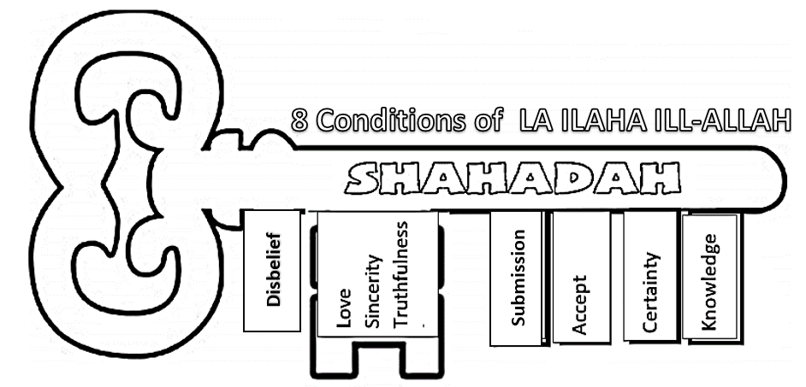
So, once we have ilm/Knowledge about Allah SWT. The next thing is to have Certainty/Yaqueen and firm belief and certainty in His Essence, His Angels, Books, Messengers, Day of Judgement and His Devine decree in every matter both seen and unseen. We then accept the terms and conditions of Allah SWT and submit/surrender with sincerity, love, truthfulness to Him and try to avoid all the falsehood/corruption that can damage our belief.
Virtues/Benefits of Shahadah to know:
The prophet SAW said:
- “Whoever dies knowing that there is no one worthy of worship EXCEPT Allah shall enter Paradise” (Sahih Muslim).

- “When a person sincerely says ‘La ilaha illallah’, the doors of the sky are opened for it until it reaches the Throne so long as he/she avoids major sins”
(Sunan Tirmidhi).
- “The best dhikr/remembrance is “La ilaha illallah”,.
(Sunan Tirmidhi).
- “If anybody comes on the Day of Resurrection who has said: La ilaha illal-lah, sincerely, with the intention to win Allah’s Pleasure, Allah will make the Hell-Fire forbidden for him.” (Bukhari)
Lesson Learnt/Reflections:
- The Shahadah is what makes our Muslim identity- everything we do revolves around our belief in Allah SWT being ultimately the ONLY SOURCE of everything! From Allah SWT we ALL came and to Him we will ALL return. Allah SWT designed and created this universe, and we all live in Allah SWT kingdom- therefore, Allah SWT makes the rules we live by. We need to know that everything Allah SWT commands us to do is for our protection (as He is the real guardian of every creation). Be certain in your heart that the only guidance is Islam- and the more knowledge you have of Allah SWT, the more you will come to accept this willingly and understand and appreciate the guidance of Islam.

- We are required to recite the Shahadah daily on average over 30 times! (Adan, Wudu and during Salah). It is a constant reminder that we are accountable for all our actions and will return to face Allah SWT with them. Allah SWT has told us that when you make Him your focus/goal he will bring the world to you and guide you, but if you make the world your objective- you forget who you are by forgetting your purpose. “And do not be like those who forgot Allah, so He made them forget themselves” (59:19).

- The Shahadah negates/removes belief or faith in anything other than Allah SWT. The most important lesson to learn is that Allah SWT forgives EVERY SIN EXCEPT SHRIK. Shirk means associating partners with Allah SWT, calling on things or people other than Allah SWT for help. This means we understand Allah SWT is the only one in control of our circumstances- we don’t consult to star signs/horoscopes, fortune telling, lucky numbers, charms, omen’s, amulets/necklaces. We have to have certainty/yaqueen without a doubt that nothing happens without the will/permission of Allah SWT, as the Prophet SAW said…. Know that what has passed you by was not going to happen you; and that what has happened to you was not going to pass you by…. (Al-Tirmidhi).

LESSON 3: SHAHADAH PART 2
Revise first part and ask a student to recall last lesson briefly.
Today we will discuss part 2 of our Key to Jannah:
which means: I believe Muhammad SAW is a Messenger of Allah SWT.
The second part is: Ashadu ana Muḥammad rasūlu llāh

A messenger/Rasool is someone who delivers a message. There were many Prophets who delivered the message of the La illah illa Allah (Ibrahim AS, Musa AS, Issa AS and others). Prophet Muhammad SAW however, is the final messenger in the chain of Prophets! Allah SWT saved the best for last! The Prophet of Islam SAW was sent as a mercy to ALL of mankind, not to a specific group or race, as we see (by looking around this room today) the message of Islam is for ALL of mankind/humanity. The most important lesson today to know is that the pathway to Allah SWT is only through following His Messenger SAW- and this is why it makes up the second half of the Shahadah/belief! So, believing in Allah SWT and the Prophet SAW go hand in hand- you can’t have one without the other.

The Prophet SAW is therefore our role model as He is described in the Quran as being the BEST of creations and “on an exalted (high) (standard) of character” (Quran 68: 4). “His SAW character was the Quran.” [Sahih Muslim]. Everything Allah SWT commanded us to do is in the Quran, Muhammad SAW modelled it for us and explained/taught it to us in his lifetime. As he SAW is the closest of creations to Allah SWT, he then taught us also how to be close to Allah SWT and establish a relationship with Him. In fact, we have over thousands of records of the sayings and teaching of the Prophet SAW, all saved and compiled in narrations called Hadith. By following the Prophet SAW we are a part of His nation- called the Ummah of Muhammad SAW.
Allah SWT reinforces this by commanding us many times in the Qur’an:
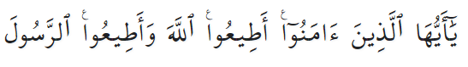
- Oh, you who believe! obey Allah and obey the Messenger (4:59)
- Say: “Obey Allah, and obey the Messenger…… If you obey him, you shall be on right guidance. (24: 54).
And whoever obeys Allah and His Messenger, Allah shall admit him in the Gardens underneath which rivers flow. (4:13) “Obey Allah, and obey the Messenger… If you obey him, you shall be on right guidance. (24: 54). And “…whoever obeys Allah and His Messenger, Allah shall allow him/her in the Gardens underneath which rivers flow. (4:13)
From these verses and many more we need to understand that the Prophet SAW had authority from Allah SWT to command and legislate Allah SWT laws on Earth. This is very important because there are some matters in Islam that are not detailed in the Qur’an. Instead, some things e.g., how to pray were shown to us by the Prophet SAW. So, we need the actions of the Prophet SAW to help us interpret the verses of the Qur’an and apply them in our lives. So, we pray the way the Prophet SAW showed us clearly.

This means that if we want to get close to Allah SWT and be on the right path to enter Jannah, we need to:
- Believe that everything the Prophet SAW told us is true. The Prophet SAW spoke about the unseen world- things we can’t see like Angels, Jannah and its levels. He spoke about things from the past (stories of past Prophets) and also advised us what will happen in the future (e.g., on the Day of Judgement).
- Love and follow the Prophet SAW by following and listening to his advice very carefully. The more we learn about him, the more we love him and try to follow him! The Prophet SAW said, “…Whoever loves me will be with me in Jannah!” (Tirmidhi). Allah SWT gave the Prophet Muhammad SAW a great deal of wisdom to teach us. The Prophet SAW explained to us what is halal (allowed) and what is haram (not allowed); what Allah SWT likes and what He dislikes. “So, take whatever the Messenger gives you and keep away from what he bans you (from)” (Quran 59:7). Remember Prophet Muhammad SAW never spoke from his own feelings/desires, he only said what Allah SWT commanded him to.
- Worship Allah SWT the way the Prophet SAW showed us. For example, in the Quran it tells us that we have to pray, fast, and give charity. The Prophet SAW showed us HOW to pray correctly so we copy his actions. He SAW taught us how to fast and do actions pleasing to Allah SWT. We do not add things to the religion- innovate/bidah and make up our own rules; this is incorrect and is not following the Prophet SAW. There is no Prophet after Muhammad SAW, and no other book after the Quran! “The Religion with Allah is Islam” (Quran 3:19) and Allah SWT promised to keep His religion (Deen) of Islam safe until the end of time!

HIS AKHLAQ/CHARACTER
The Prophet SAW also told us “I have been sent to perfect good character.” (Al-Muwaṭṭa’ 1614). Meaning he SAW is our mentor on how to best handle any situation we experience- in a way most pleasing Allah SWT. The Prophet SAW displayed good character by being:

- Honest:
One of the most important characteristics the Prophet taught us was truthfulness and honesty. Before becoming a Prophet, Muhammad SAW was well-known in Makkah as As sadiq (the truthful) and Al-Amin (the trustworthy).

- Kind and Merciful:
The Prophet SAW said: “Verily, kindness is not found in anything except that it beautifies it, and it is not removed from anything except that it disgraces/ruins it.” (Sahih Muslim)
The Prophet encouraged greatly showing kindness in every matter “Every act of kindness is charity.” Every little act of thoughtfulness is equal to giving charity.
Muhammad SAW teachings therefore made him the most influential person in History (google it!). Throughout his life his teachings changed humanity for the better. E.g., Muhammad SAW was the only person in the entire history (to date) who was able to remove racism, alcoholism, adultery, immoral behaviour, and many more injustices (including the incorrect treatment of women) successfully from a society. Muhammad SAW mercy and kindness was contagious as people from all walks of life were and still are today being transformed into the humblest of souls through following him.

Lessons learnt/reflections

- WHO DO YOU FOLLOW? Remember the Shahadah is repeat constantly to remind us of who we are – we are people who believe in Allah SWT and follow the Prophet Muhammad SAW. Muhammad SAW is a positive role model who inspires us to be better people! Ask yourself: Who do you really love and follow? In today’s social media world, we are always liking and following certain celebrities, youtubers etc. Be careful who you follow because these people may do haram things and following the wrong behaviour/trends can lead you away from Islam. Before you make that video or type that comment or send that pic, please ask yourself… would Allah SWT and His Prophet SAW approve of this? Will this help me get into Jannah? remind yourself that you are a Muslim who is honoured by Allah SWT, even Angels make Dua for you!

- Following the Prophet SAW means gaining his support/intercession on Judgement Day. His followers will stand near him on that day and the Prophet SAW will make Dua to Allah SWT until his entire Ummah enters paradise. The gates of heaven have been instructed to open for Muhammad SAW - so, who do you want to be next to on that Day? Learn about him so you can really love him and be like him. Remember, the Prophet SAW said, “…Whoever loves me will be with me in Jannah!” (Tirmidhi).

- We worship Allah SWT not the Muhammad SAW. Muhammad SAW whilst being the greatest of creation is only a man who like us is at the also at the mercy of Allah SWT. We do not pray to him or ask him to grant us our Dua, again this dangerous and is a form of shirk. He SAW warned us and said: “Do not exaggerate about me…. for I am just a slave, so say ‘The slave of Allah and His Messenger.” (Al-Bukhari).

EXTENSION Reflection: What hadith do you know? What practices of the Prophet SAW, do you do every day? (Saying Bismillah before anything, using right hand to eat, spreading Salam, smiling, obeying parents etc).
- Increase your love and be closer to the Prophet SAW in both this life and the next by continuously sending your salawat. “Whoever sends salah upon me once, Allah SWT will send salah (honour) upon him/her TEN-FOLD, erase ten sins from him/her, and raise him/her 10 degrees in status” (Nasai). “The closest people to me on the day of judgement will be those who send the most salawat upon me” (Tirmidhi).

The Intercession of Prophet Muhammad
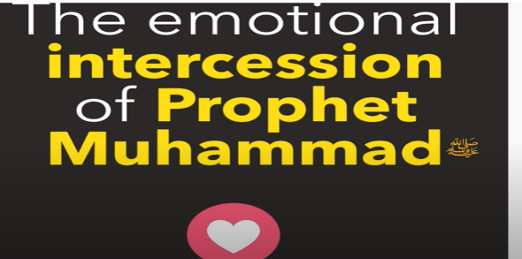
https://youtu.be/SkMWZhmRhV0

You can’t deny Prophet Muhammad ﷺ
https://youtu.be/QjjO485XiQE
LESSON 4: PILLAR TWO: SALAH
After we have understood our Shahadah, the next step is to show this belief with your actions, this is why the next pillar is the Salah (Pillar 2). Salah is the physical submission and spiritual humbling before Allah SWT. You have acknowledged your creator and Prophet in Pillar 1 (inwardly), now you need to show your belief outwardly!
Allah SWT ascended His Prophet SAW to the heavens (on a night journey) in order to receive this special gift. Salah is therefore the most important good deed to perform! Salah comes from the word Silah- which means to connect. We were given this gift by Allah SWT to establish and strengthen a connection with Him. Salah also means a Dua- invoke, call out to Allah SWT. Salah is the way we show Shukr/ gratitude to Allah SWT for all the favours, blessings He has blessed us with. “And if you should try to count the favours of Allah you could not count them.” (14:34). The Angels of Allah SWT are constantly worshipping Him- yet on the day of Judgment they will say: “Glorified are You; We have not worshipped You as You deserve to be worshipped” (Ibn Kathir in at-Tafsīr ). So, what about us? Out of His infinite mercy, Allah SWT made only 5 obligatory prayers. Each prayer only takes on average 5 minutes. That’s less than half hour throughout a 24-hour day to prostrate our head to the ground, and show humility to the Lord of the Worlds (Rabb Al-Alameen).
When we hear the call to prayer/adhan, Allah SWT tells us “Hayya ‘ala- Salah” (hurry to salah), “Hayya 'ala-l-Falah” (hurry to success). Therefore, the only way we can succeed in this life and the hereafter is to hurry to Salah. Without salah there is no success!
This is why Allah SWT made Salah compulsory. Salah reminds you of Allah SWT, when you get up in the morning, it reminds you three more times when you are busy during the day, and once again before you go to bed. It keeps your heart grounded and checked in to your purpose. Allah SWT commanded the salah in order to help you develop faith, purify yourself, develop excellence in character and always remain conscious/awareness of Him at all times.

The Prophet SAW warned us that: The first action for which a servant of Allah SWT will be held accountable on the Day of Resurrection will be his prayers. If they are in order, he will have prospered and succeeded. If they are lacking, he will have failed and lost. If there is something defective in his obligatory prayers, then the Almighty Lord will say: See if my servant has any voluntary prayers (sunnah, nawafil) that can complete what is insufficient in his obligatory prayers. The rest of his deeds will be judged the same way. (Source: Sunan al-Tirmidhī: Sahih)

The 5 obligatory/fard prayers are as follows*Write on the board if possible and repeat the names of prayers and number of rakat/units clearly. (Questioning students for answers as you write).
Name of Salah | Fajr | Dhur | Asr | Maghreb | Isha
Number of Rakat/units | 2 | 4 | 4 | 3 | 4

Ask the total? Total number of Rakat = 17. That’s 17 times you read Al-Fatiha- asking to be guided to the Sirat Al-Mustaqueem (straight path), you also praise Allah SWT over a thousand times in one day! (Allah Akbar, Subhan Allah etc). You bow your head/ prostate on the ground- on average 17 times repeating the Shahadah and reminding yourself of your place and purpose.
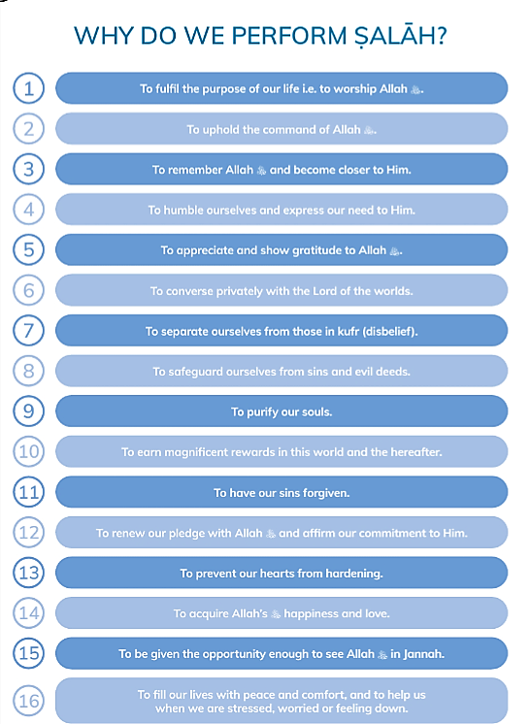

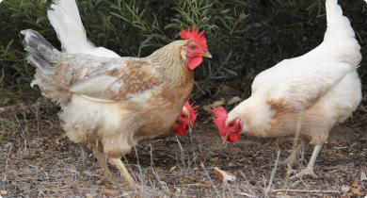
How strong is your connection? Think of your Wi-Fi connection the signal bars. We need full signal of concentration to communicate with Allah SWT. “Salah nourishes the heart just as food nourishes the body. And just as the body isn’t nourished by little food, the heart isn’t nourished by pecking (rushing) in the prayer” (Majmoo’Al Fatawa).

Correct wudu is the key to Salah. He SAW said that “Cleanliness (or ‘taharah’ in Arabic) is half of the faith (Eman).” [Sahih Muslim]. This means cleanliness and purity are part of our faith it is the basis of our Iman; we have to take it seriously for our spiritual growth. If your tahara is lacking this will carry over in your salah.

Wudu is your light on the day of judgement so don’t rush it and perform it correctly.
The Prophet SAW said, “Verily my people on the Day of Judgment come with white light in all members of the ablution (limbs washed and wiped in wudu) from the former ablution. Whoever of you can prolong his white light, then let him do that.” (al-Bukhari and Muslim).
(Do not show Wudu rather advise to ask an adult or family member if they are unaware or they can search it in an app, you tube link etc.)
** Note: Major impurity means; menstruation cycle for women, wet dreams for both men and women. In these case GHUSL (full shower or bath) is required and is important as Salah will not be valid). (***Please define wet dreams in medical terms- as hormonal body fluids that are released during sleep).
(*Note: Do not show students how to pray- due to different sects rather just an explanation of salah and motivating student to pray/Virtues of Salah- advise always to ask a family member or encourage them to research/internet the Prophets prayer via videos or buy a book).

Some virtues of Salah
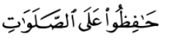
- The 5 daily prayers build a powerful defence against evils which exist around us. It is said in the Holy Qur’an that, surely, Salah keeps you away from indecency/filth and evil. This is why the prayer is described as “remembrance” to Allah SWT. If we want to safe guard our souls, heart and mind we need to establish the salah in our lives. Salah acts as your protective force against harm! For this reason, Allah SWT command’s, us to “Guard strictly (five obligatory)” (2:238)

- Salah also wipes out our sins! Prophet Muhammad SAW once questioned his companions “Tell me if there was a river at the door step of one of you in which you washed 5 times a day would any of your dirt remain?” When he received the reply that none of it would remain, he then said “That is like the five times Salah, with which Allah SWT wipes out our sins”. Imagine every time you pray you are removing all the negative energy, minor sins, bad words, you are literally editing your book of deeds- by erasing the wrong (minor) choices! You are also being raised in your rank for every sajdah you do!
“Ṣalāh brings provisions/rizq, preserves one’s health, removes pain, repels illnesses, strengthens the heart, brightens the face, brings joy to the soul, removes laziness, stimulates the limbs, fuels one’s strengths, brings peace to the heart, nourishes the soul, illuminates the heart, preserves blessings, repels calamities, brings blessings, pushes shayṭān away, and brings one close to the All-Merciful.” - Ibn al-Qayyim

Lessons learnt/Reflections (it is suggested to watch a link before discussion)
- Salah is for our benefit and will serve as our light in both this life and the next. Allah SWT has honoured us through Salah. In comparison to Allah SWT your non-existent, yet He is calling you 5 times a day to speak to Him personally! You are therefore very special to Allah SWT!!

- There are no excuses to miss this pillar! Reflect today, what’s the struggle? if you are not praying - what is it that is preventing you from getting closer to Allah SWT? If you are delaying your Salah or missing some prayers, why? What excuse(s) will you give Allah SWT on that day? The Prophet SAW has warned us that “Between faith and disbelief is abandoning the prayer.” (Muslim, Abu Dawud, Tirmidhi). If we lose our connection, we are in danger of losing Islam! Start connecting today don’t delay!!
**Some suggestions are fixing your environment create a salah zone away from distractions. If you don’t know how to pray- ask an adult to teach you and show you Wudu and Salah steps or research it with Google, YouTube or books!
**Find a prayer buddy. The Prophet SAW said, “A man is upon the religion of his best friend, so let one of you look at whom he befriends.” (al-Tirmidhī). Do your friends encourage you to pray? Do you surround yourself with people that remind you of Allah or push you away from His guidance?

**Download an app that gives you notifications of prayer times so you can be alert and prayer on time. The Prophet SAW said:
“The best deeds is the prayer/salah at its earliest time” (Tirmidhi, Sahih).

- Understanding what you are saying in Salah will help you concentrate and be present more. Surah Al-Fatiha is compulsory in every unit of Salah, therefore we should attempt to understand what it means if we are reciting it on average 17 times a day! (offer the hand out or/and go through it with the students if you wish). The words in this Surah are so powerful that Surah Al-Fatiha is also called Ash-Shifa, meaning, The Cure. It is also a Dua/prayer where we are asking Allah SWT over and over to guide us “Ihdinas Siraatal Mustaqeem” (Guide us to the straight path) (1:6)! We also end Al-Fatiha with? …Ameen! And the Angels say Ameen too with us for our Dua! Muhammad SAW said “If anyone of you says; “Ameen” and it coincides with Angels; all his past sins will be forgiven” (Sahih al-Bukhari).

- Salah is one of the major ways we show obedience, love and gratitude to Allah SWT!...Start by making that first sajdah and asking Allah SWT to help you! Allah SWT says “My servant does not come closer to Me with anything more dear to Me than that which I made obligatory upon him/her. My servant keeps coming closer to Me with more volunteer deeds, until I love him/her…” ****(Bukhari)

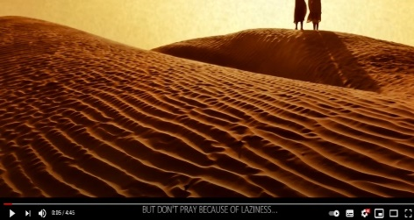
Prayer Links that can be used throughout the year.
https://youtu.be/su36jQccoqY
Why Don't You Pray?

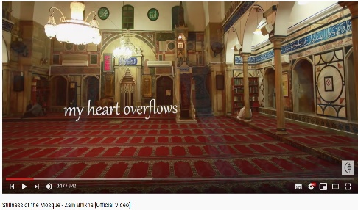
https://youtu.be/rDEo9rc5Mlg

Stillness of the Mosque - Zain Bhikha

[Official Video]

Why Don't You Pray? | Whispers | Ep 1
https://youtu.be/3o8EWTd5isw

LESSON 5 : PILLAR THREE, FOUR AND FIVE
Zakat is the 3RD pillar following Salah. Allah SWT says in the Qur’an “Keep up Prayer and pay Zakat” (24:56). There are two types/definitions of charity in Islam; Zakat and Sadaqah.
Zakat is obligation/compulsory if you can give it (obviously the poor Muslims are not obliged), and Sadaqah is any act of voluntary kindness/charity (e.g., such as smiling!).

Zakat is therefore a charity given to those in need, therefore this pillar is all about looking after other people. Zakat means to purify and cleanse our wealth. Each Muslim who has a certain amount of extra wealth, needs to share this with those who are less fortunate. This act of Zakat is commanded in order to protect us from being stingy, greedy and selfish. Islam is a selfless religion we are obligated to think of those who are less fortunate than us.

A very important thing that we should always remember as Muslims is that everything we own is from Allah SWT. For this reason, it is our responsibility to give back and share our wealth. In return for giving the Zakat, Allah SWT will purify and bless our wealth more and reward us with infinite hasanat! “Truly he/she succeed who purify it (soul), and he/she fails that corrupts it! (91:9-10).

There are 2 types of Zakat…
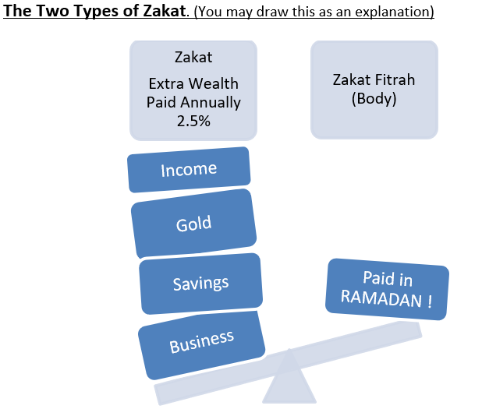
1. Zakat of Wealth is a yearly compulsory charity payment upon every adult Muslim, who has over a certain amount of savings. Zakat is only a small amount that Allah SWT asks us to share – only 2.5% of our savings. For example, if it was $100 that we saved up, we’d only need to give $2.50 away!
2. Zakat Al-Fitr is a Zakat that is given at the end of Ramadan each year. It is to be paid by every man, woman and child and can only be given to the poor. Zakat Al-Fitr is all about thinking about others and making sure everyone gets to celebrate Eid comfortably financially.

Fasting/sawm is the 4th pillar of Islam. Fasting in general means to stop eating and drinking. However, this pillar is not simply about our stomachs; it is so much more. Each year there is a special month called Ramadan that all Muslims around the world fast during. In Islam we follow a lunar/moon calendar that goes by the moon cycles- (this is why Ramadan falls on a different month every year). There are 12 months in the Muslim calendar (just like the Gregorian calendar Jan-Dec) and Ramadan is the ninth month (Ask: is anyone familiar with the Islamic months, do you know any?). What month are we in now?
This year Ramadan will begin approximately 2nd April Inshaa’ Allah. The month of Ramadan begins when the new moon/cycle appears. The moon looks like a banana shape (crescent). Once we see the new moon, we fast the entire month (29 or 30 days) from sunrise (Fajr) to sunset (Maghreb) (reinforce Salah names).
- This special month is our opportunity once every year where Allah SWT showers us even more with His mercy. Have you ever noticed how easier it is to fast in Ramadan- in comparison to the other days of the year? This is because in this month the 8 gates of heaven are open! Allah SWT Mercy/Rahmah is showered on the earth and placed in our hearts. Making our hearts more soften and tranquil Subhan Allah.
- Ramadan is a month where deeds are multiplied and amplified. Every year we are given the opportunity by Allah SWT to increase our tally of hasanat and also start fresh spiritually! In particular on a special night called laylat Al-Qadr/The night of Power. This night is the highlight of Ramadan, as it is better than 1000 months of worship! (we will discuss this more in Term 2).
(We will discuss how to prepare in detail in our last lesson)

Hajj/Pilgrimage to Makkah is the 5TH Pillar Allah SWT has asked all Muslims, who are financial and physically able- to perform Hajj by visiting the Kabbah in Makkah, Saudi Arabia. Hajj only happens once a year and is a very special trip - there were over 2.4 million Muslims who did Hajj last year! Some important days of Hajj are the Day of Arafah and Eid al-Adha. We will learn more about these blessed days later in the year, Inshaa’Allah. But for now, just know that this journey is the journey of a lifetime for young and old-where everything we talk about becomes a reality as we walk in the footsteps of the Prophet (s) and enjoin in many historic rituals that make up our Islamic identity!

Let’s Recall & Revise (let the students answer)

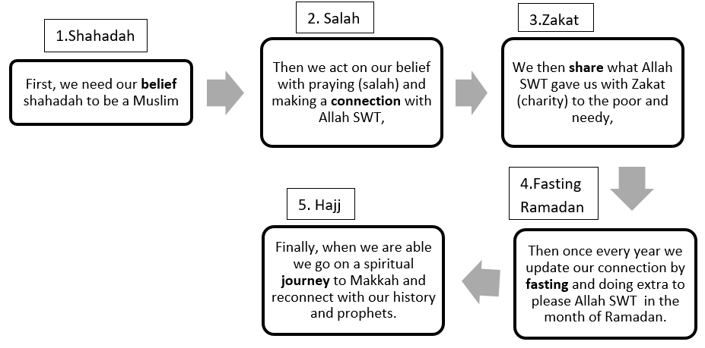

LESSONS LEARNT/Reflections: What is the importance of these Pillars - why do we need them?
- Just like a pillar in a building supports its structure, the 5 pillars of Islam help us uphold our religion by better perfecting our character. Making mistakes, forgetting, and committing sins are all part of being human. Allah SWT created us and knows exactly what our nature is, it is for this reason He gave us these 5 pillars to uphold His message and keep us steadfast and guided on His straight path (Sirat Al Mustaqueem).
- By applying these pillars properly, we are constantly purifying our souls and seeking the forgiveness and mercy of Allah SWT. Zakat purifies our wealth and encourages us to think of others, Ramadan is like a reset button where we stop and reflect, Hajj is a journey of forgiveness and mercy where you can return sin-free (like a newborn). Subhan Allah if we look at all these pillars, we will see the constant mercy of Allah SWT to keep us close to him and to forgive us. It only takes one sincere repentance and Allah SWT will erase all your sins or convert them into good deeds!
- The most frequent Dua the Prophet SAW would say to stay steadfast was: 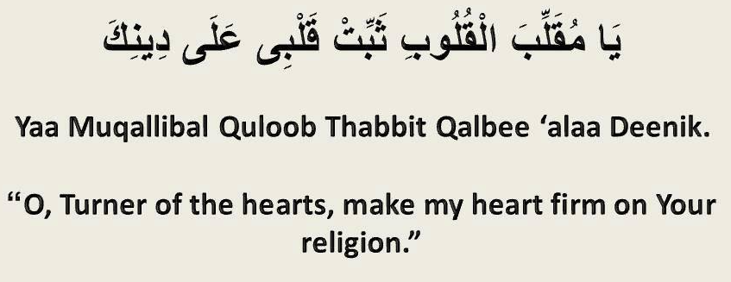
- Islam is complete, relevant and valid to every era or place and will continue until the final days on Earth as Allah SWT has told us. The pillars serve as a protection in this life and the afterlife.

The Prophet SAW said: …By He Who owns my life! The dead person hears the sound of your slippers (or shoes) when you depart and leave him. If he is a believer, the prayer/salah will stand by his head, Zakah to his right and the fast by his left; the righteous deeds, such as charity, keeping relations with kith and kin and acts of kindness to people will stand by his feet.
LESSON 6: The Qur’an
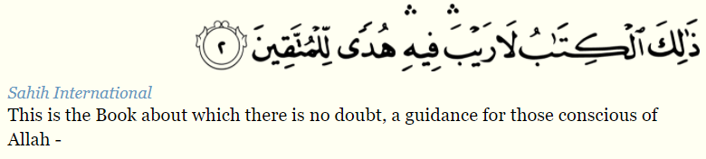
The Qur’an is the divine scriptures of the eternal speech of Allah SWT. The Quran was revealed to Prophet Muhammad SAW through Angel Jibril, 1400 years ago over a period of 23 years. This means it was sent down gradually throughout the Prophet SAW lifetime. The Prophet SAW was 40 years old when he first received the first message from the Qur’an.
*Ask: Does anyone remember the first word to be sent down (from the heavens)?
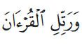
The message of guidance to the entire world began with “IQRA” (read/recite). This was the first instruction from Allah SWT’s to humanity- read (in order to seek knowledge). In fact, the literal meaning of the word Qur’an means to recite: “for it is a Book to be recited (73:4),

*Quick Quiz how well do you know your scripture book?

(**Teachers please bring in a Quran to familiarise students if possible).
- The Quran is made up how many chapters.... 114 chapters.
- A chapter is called a?... SURAH
- These chapters have verses/like a sentence called an? …AYA
- There are over how many Ayat in the Quran? 6000. That’s over 6000 notifications/messages you need to IQRA from Allah SWT.
- The Suwar were revealed in two places and you can see find out in the contents page
(Either in Makkah where Prophet was born, or Medina when he migrated).
- Explain referencing on board e.g., when you see (15:2) it means Surah 15 verse 2.
(Suggested fun activity, teacher can select a reference and student can try to find it and read it out loud- please prepare a suitable verse ahead of time if doing so**).
The Qur’an is our ultimate guide it instructs us:
- About Allah SWT and His characteristics, and why He created us.
- How to show the best of manners to everyone, especially our parents and families.
- About the world we live in and His creations and even creations outside our world (space and galaxies) -Science, geography, embryology, anatomy, psychology and so much more!
- About our body and how to look after it.
- How to worship Allah through praying, fasting, making supplications/Dhikr, (special words we use to say to honour Allah SWT, Our Creator).
- The history of other people who lived before us- what happened to those who CHALLENGED ALLAH SWT!!
- Stories of the past prophets/people. These stories teach us about patience, Iman, relying on Allah alone/Tawwakul, courage and strength.

Why the Qur’an is CRITICALLY Important in our lives?
Allah SWT sent down the Quran literally from the heavens. The Qur’an is so heavy in weight that Allah SWT sent it down gradually to strengthen the heart of the believers. The Qur’an is our source of light and guidance without it we will be lost and confused about our purpose and existence.
The Prophet Muhammad SAW said, “Indeed this Qur’an is a rope – one end of it is in the Hand of Allah and the other end is in your hands. So, hold firmly to it [the result would be] that you would never go astray and never be destroyed [no matter what the circumstance].”
Source: Ibn Hibban no. 122 - [Sa-hih]
Imagine a rope coming down from the heavens, the Quran is the rope that connects you with Allah SWT. When we Abandon the Qur’an we are letting go this rope the source of guidance and light!

Virtues of the Quran- Reciting Qur’an is worship/ibadah

- RECITE AND RISE UP…A Muslim’s status is raised by the Quran – the more he/she recites, follows its commandments and makes Quran part of his or her life, the more Allah SWT will elevate his or her status in this life and hereafter.

- The reward of reciting Qur’an is Ten Rewards for each letter!! “Whoever reads a letter from the Book of Allah, he will have a reward. And that reward will be multiplied by ten. I am not saying that “Alif, Laam, Meem” is a letter, rather I am saying that “Alif” is a letter, “laam” is a letter and “meem” is a letter.” (Tirmidhi).

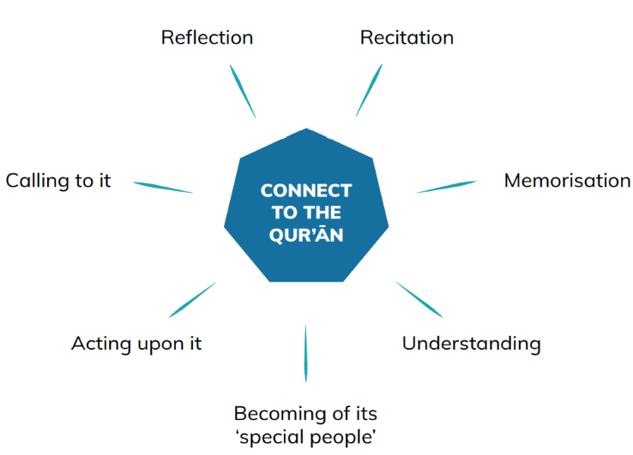
Lesson learnt/reflections:
- Allah SWT wants us to reflect, think, explore and learn about this universe and our purpose. The Qur’an was not sent to be only recited and memorised rather we are commanded to apply it in our everyday life. When we recite an aya we need to reflect how we can implement/apply the aya in our lives.
- E.g the Aya regarding parents: say not to them [so much as], "uff," (17:23) How can we start to live by this??
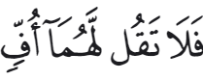
- Start to Connect with the Qur’an daily: Even if you can’t read Arabic: Listen to the Qur’an every single day. Literally be plugged in…the words of Allah SWT keep us guided and remind us to do good. Listening to the Qur’an softens your heart and purifies it. Every word in the Qur’an is described by Allah SWT as a good word with blessings/barakah/healing.

- Allah SWT has told us that; And We have certainly made the Qur'an easy for remembrance, so is there any who will remember? (54:17). It is therefore an obligation on all of us to learn how to recite the Quran. Don’t be overwhelmed! Remove ‘I can’t’ from your vocabulary and remove the negative thinking, put your trust in Allah SWT, and strive with your actions.
We need to make the effort to learn Arabic, the language of the Qur’an. This may seem hard at first, but Allah SWT rewards our efforts double for our struggle initially learning the Qur’an…. the Prophet SAW said, “Such a person as recites the Qur’an and masters it by heart, will be with the noble righteous scribes (in Heaven). And such a person exerts himself/herself to learn the Qur’an by heart, and recites it with great difficulty, will have a double reward.” (Al-Bukhari). Check and ask your local masjid and Islamic centres there ae always programs running with Qur’an classes.

- Qur’an is your protector in both this world and the next. The Prophet SAW said “Recite Qur’an. Indeed it will come on the Day of Judgement as an intercessor/(that defends) for its companions/friend (Muslim).

- Muhmmad SAW said, “The best of you are those who learn the Quran and teach it.”
(Ṣaḥīḥ al-Bukhārī). Anything you learn share it with family and friends to receive ongoing rewards!

GREAT BENEFITS BEHIND READING QURAN
https://youtu.be/mROomlWvlwI

LESSON 7: Preparation for Ramadan/ Revision
What is the most important month of the year for a Muslim? Ramadan of course! Allah SWT has made it clear “And I did not create …mankind except to worship Me”, (51:56) Our purpose and our relationship with Allah SWT should become much better in the blessed Month of Ramadan. Your happiness depends on your relationship with Allah SWT now is the time to improve or establish one.
What does Ramadan mean to you? Is it just about food and traditions, if so it’s time to reprogram yourself because you are missing out on the infinite rewards! Allah SWT makes us stop physically feeding our bodies, so we concentrate on feeding our hearts and souls instead. The food source in Ramadan is the Dhikr/remembrance of Allah SWT! This is the importance of Ramadan to become more aware and mindful of Allah SWT (obtain taqwa). "O you who believe, the fasts have been enjoined upon you as they were enjoined upon those before you, so that you may have taqwa" (2:183)
Think about an athlete that runs a race, or your favourite sports team about to play a match. Do they just wake up on the day of the race/match and play -or have they been training for weeks (or even months) ahead of time! Similarly, it was from the traditions of the Sahaba that they would prepare for Ramadan six months in advance. They would pray to Allah SWT for forgiveness, and pray that Ramadan would arrive in a time where they were at the peak of Iman. For five months after the completion of Ramadan, the Sahaba would ask Allah SWT to accept their deeds. Subhan Allah. We don’t need to wait for Ramadan to start practicing being better Muslims we can start training today with everything we have learnt this term.
- A man asked the Prophet SAW, “What kind of deeds are the BEST in the sight of Allah SWT?” Prophet Muhammad SAW replied, “to pray on time.” (Sahih al Bukhari, 2782). This is the first thing we need to get right before Ramadan comes - our Salah! If you know how to pray, ask an adult to teach you. Start today. If you do pray, are you doing all 5 salat? Try to practice not skipping any salah for one whole day, then for another and another… Our compulsory pillars, like Salah, come first before any extra actions. In Ramadan there are extra prayers called Taraweeh. We need to complete our 5 prays compulsory salah first. Let’s concentrate on and fix up our Salah, before Ramadan, so that when it starts, we are able to add additional prayers and reap more rewards! For those who do pray, how is your Fajr? Again, waking up for Fajr will train you for Ramadan to wake up at Suhoor/ predawn meal time.

- Make up any missed days. If you were sick during last Ramadan, be sure to try your best to make up for your missed fast ASAP! You may also practice voluntary fasting on Monday and Thursday to train your body ahead of time.

- Reciting or listening to Quran. We know Ramadan is the month of the Quran, start listening more today, start reciting more. IQRA, IQRA, IQRA! Recite Allow your body to become used to hearing the words of Allah SWT. Try to learn a new surah/chapter from now until Ramadan. Music is like the alcohol for ears, start detoxing today!

- Learning the fasting Dua. In Ramadan, there is a Dua we say when we break our fast. Please ask an adult to help you learn it over the school holidays before Ramadan, or watch the following link repeatably. Dua after Breaking Fast (Memorization) https://youtu.be/HRM6RgExWNg
“ZHAHAB- AZ- ZAMUAU’- WABATALLAT-IL-UROOQU-WA THABAT AL AJRU INSHAA ALLAH”
“The thirst has gone, and the veins are quenched, and reward is confirmed, if Allah wills. (Abu Dawud 2/306, Sahih Al-Jami As Saghir 4/209)
- Go to bed early! One hour before bedtime, switch off your electronics! Our bodies are designed in such an amazing way that some organs only work at night while you are sleeping! We need to give our bodies time to repair and fix themselves, this process happens while you sleep. When we sleep early, we have more energy. In Ramadan you need plenty of energy! If you are a late sleeper this will be difficult. Do you istaghfir/repentance whilst assessing your day and think about what you can do better.

Checklist suggestions
- Perfect my salah, pray on time pray with care.
- Clean my room/ environment! Decluttering can help your mental clarity.
- Create a clean, special place to read Qur’an and perform my Salat and tasbeeh.
- Listen to lectures about Ramadan to get your mindset ready!
- Social media decluttering- start deleting and blocking what and who is no good for your spiritual growth!!!
- Practice a Surah or listen to Qur’an every day for at least 10 minutes.
- Practice Dhikr- for example, Subhan Allah wa bi hamdi, Alhamdullilah, Bismillah
- Sleep early, switch off devices 1 hour before bed
- Drink, drink, drink plenty of water!!
- PRACTICE the Dua every day for 5 minutes until I know it
- Practice my manners, help out where I can.
- Save time, clean home prior to Ramadan, go Eid shopping early save time and energy! Do not waste the most important last ten nights shopping!!!!
- Practice eating healthy, wholesome foods like fruit and veggies and reducing junk food. Try dates!
Make a plan for Ramadan and set yourself at least one goal to improve yourself
THIS RAMADAN I AM GOING TO PERFECT ONE DEED? WHAT IS IT?

–e.g. improve my manners, not get angry, practice talking politely, fix my relationship with family members, reduce screen time.
What else can you think of to prepare for Ramadan?

- Stating our intention before completing any act of worship helps us to reconsider the reasons why we are doing something, and also re-focuses our attention toward what is best for us
- Work together with a friend or relative so that you can both commit to making this Ramadan the most outstanding one you’ve ever had. Having additional motivation will help push you to achieve the goals you have set for yourself, Inshaa’ Allah.
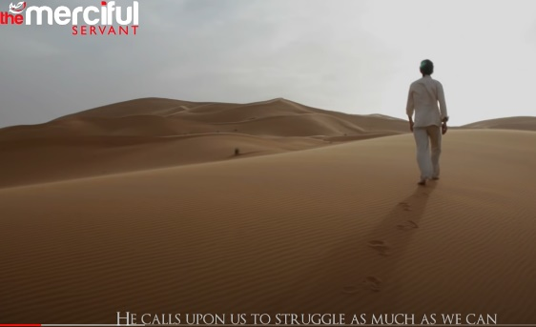
Allah Chose You For Islam - Powerful Reminder
https://youtu.be/Y_0Igrldb54

***Teachers, please wish all students a safe holiday. May Allah SWT reward you for your efforts. Jazakum Allahu Khayrun!
Prophet SAW said “Whoever guides someone to goodness will have a similar reward” (Muslim)

